Internship Report
Of

Web Development
"ShopEase —A Responsive E-Commerce Website"
Submitted
To
School of Computer Science and Engineering IILM University, Greater Noida, U.P.
In partial fulfilment of the requirement of degree of
B.Tech CSE

Roll Number of Student: 25SCS1003003951
Name of Student: SAKSHAM SAXENA
Batch: 2025-2029

CANDIDATE'S DECLARATION
l, Saksham Saxena, do hereby declare that the internship report titled "ShopEase — A Responsive E-Commerce Website" has been completed by me to fulfil the requirement for the award of the degree of Bachelor of Technology in Computer Science and Engineering. All the references have been quoted and I have not taken as such any material from any other source. I affirm that this report is my own work and has not been submitted to any other institute for any degree/diplomå requirement, and further I shall be solely responsible for any kind Of copyright violation in this regard.
Signature
Student Name: Saksham Saxena
Roll NO.: 25SCS1003003951

ACKNOWLEDGEMENT
I am using this opportunity to express my gratitude to everyone who supported me throughout the internship program. I am thankful for their aspiring guidance, invaluable constructive criticism and friendly advice during this work. I am sincerely grateful to Codec Technologies Pvt. Ltd. and the National Internship Portal for providing me the opportunity to undertake this Web Development internship, and to my mentors for sharing their truthful and illuminating views on a number of issues related to this work.
I would also like to thank the School of Computer Science and Engineering, IILM University, Greater Noida, for their continuous support and encouragement throughout this internship.
I express my gratitude to my parents for their blessings
Signature
Student Name: Saksham Saxena
Roll No.: 25SCS1003003951
INTERNSHIP COMPLETION CERTIFICATE
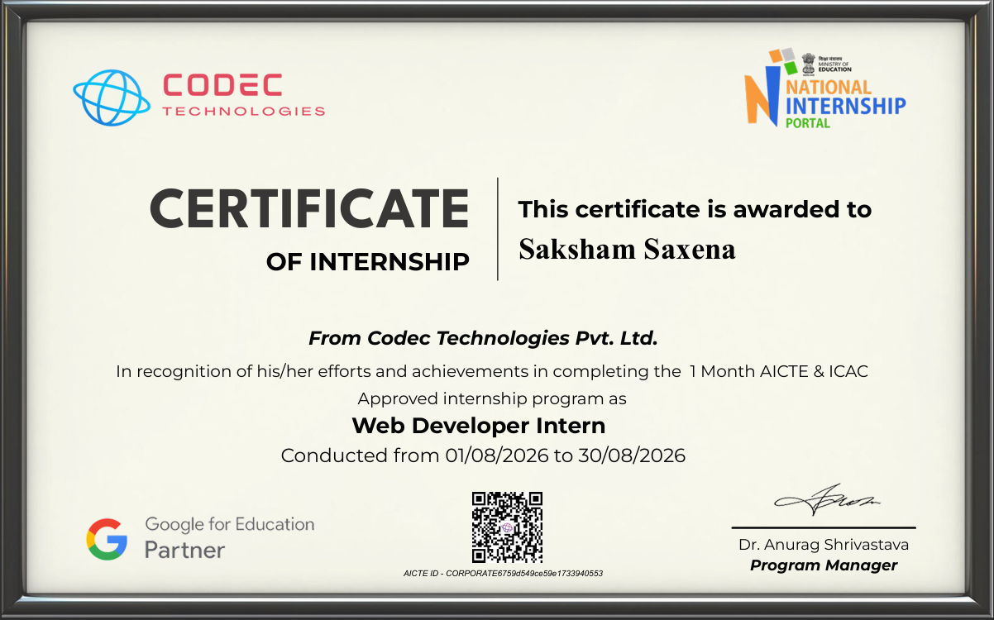

TABLE OF CONTENTS
Chapt er No. | Chapter Name | Page Nos.
 | Cover Page
1, | Candidate's Declaration
2, | Acknowledgement
3. | Internship Completion Certificate
4. | Project Description  4.1 Introduction  4.2 Organization Profile  4.3 Problem Statement  4.4 Project Objectives  4.5 Scope of the Project  4.6 Technologies and Tools Used  4.7 System Architecture  4.8 Methodology  4.9 Expected Outcomes  4.10 Certificate of Completion & Communication Proof | 1-9
5. | Bibliography / References | 10

4. PROJECT DESCRIPTION
4.1 Introduction
This report presents the work carried out during a one-month Web Development internship undertaken with Codec Technologies Pvt. Ltd. under the AICTE & ICAC approved internship program hosted on the National Internship Portal. The internship focused on strengthening practical skills in front-end web technologies and applying them to build a functional, responsive web application. As part of this internship, a project titled "ShopEase — A Responsive E-Commerce Website" was designed and developed, covering the complete workflow of planning, designing, coding, testing and refining a real-world style web application.
The internship provided hands-on exposure to industry-relevant tools and practices such as version control using Git and GitHub, responsive design principles, and client-side scripting using modern JavaScript. This chapter describes the organization, the problem addressed by the project, its objectives, scope, the technologies used, the system architecture, the methodology followed, and the outcomes achieved.
4.2 Organization Profile
Codec Technologies mrt. Ltd. is an ed-tech and skill-development organization that partners with the National Internship Portal (an initiative recognized under the Ministry Of Education) to deliver AICTE ICAC approved internship programs to engineering and technology students across India, The organization, in association with Google for Education, conducts structured, mentor-guided internship programs in domains such as Web Development, Data Science, Machine Learning and Cybersecurity.
The Web Developer Internship program is designed to help students move from theoretical classroom knowledge to practical, project-based learning by exposing them to real development workflows, coding best practices, and the use of modern front-end frameworks and tools within a short, intensive duration.
4.3 Problem Statement
Small and first-time online sellers often struggle to showcase their products on the web without investing in a heavy, expensive e-commerce platform. Most beginner-friendly

templates are either not responsive, lack a working shopping cart, Or do not allow users to search and filter products efficiently. There is a need for a lightweight, responsive e, commerce front-end that lets a visitor browse products, filter/search them, and add them to a cart, with the cart data persisting even after the page is refreshed — without depending on a heavy back-end infrastructure.
4.4 Project Objectives
To design a clean, responsive, multi-page e-commerce website that works seamlessly across desktop, tablet and mobile screen sizes.
To implement a dynamic product listing page with category-based filtering and keyword-based search.
TO build a fully functional shopping cart that supports adding, updating quantity, and removing items.
To persist cart data across page reloads using the browser's localStorage.
To validate and handle a working contact/enquiry form on the client side.
To follow good coding practices, semantic HTML structure, and maintain the project using GiUGitHub version control.
4.5 Scope of the Project
The scope of the project is limited to the front-end Of an e-commerce website. It includes a home page, a product listing page with filter and search functionality, a product detail view, a shopping cart page, and a contact page. The project uses static/local JSON data to simulate a product catalogue rather than connecting to a live back-end server or payment gateway, since the focus of the One-month internship was on front-end development, responsive design and client-side logic. Integration with a real back-end, database and payment gateway is identified as a natural extension Of this project beyond the internship duration.
4.6 Technologies and Tools Used
The following table lists the major technologies and tools used to build the project.
Category | Technology / Tool | Purpose
Markup & Styling | HTML5, CSS3, Bootstrap 5 | Page structure and responsive UI design
Scripting | JavaScript (ES6) | Cart logic, search}filter, form validation
Data | JSON | Local product catalogue
Storage | Browser localStorage | Persisting cart data across sessions
Version Control | Git & GitHub | Source code management and versioning
Tools | VS Code, Chrome DevT001s | Development, debugging and responsive testing
Table 4.1: Technologies and Tools Used
4.7 System Architecture
The project follows a simple client-side layered architecture. The Presentation Layer (HTML/CSS/Bootstrap) renders the responsive user interface. The Application Logic Layer, written in JavaScript, handles cart operations, product filtering/search and form validation, The Data Layer supplies product information from a local JSON file, while the Browser Storage layer (localStorage) persists the shopping cart between sessions. Figure
4.1 below illustrates this architecture.
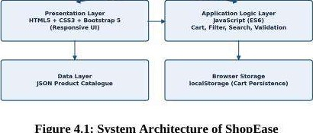
Figure
4.1:
System
Architecture
of
ShopEase
use
r
4.8 Methodology
The project was developed in the following stages:
Requirement Analysis — Identifying the core pages and features needed for a basic e-commerce experience.
Design — Creating wireframes and deciding the layout, colour scheme and navigation flow for all pages.
Development — Building the HTML structure, styling with CSS/Bootstrap, and implementing JavaScript logic for the cart, search and filters.
Testing — Cross-checking responsiveness on different screen sizes and validating cart and form behaviour.
Refinement & Deployment — Fixing bugs, optimizing code, and pushing the final version to GitHub.
4.9 Expected Outcomes
A fully responsive, multi-page e-commerce website front-end that works across devices.
A working shopping cart with add, update and remove functionality, persisted via localStorage.
A searchable and filterable product listing page,
Improved practical proficiency in HTML5, CSS3, Bootstrap and JavaScript (ES6). Hands-on experience with Git/GitHub-based version control and a structured development workflow.
4.10 Certificate of Completion and Other Communication Proof
The internship completion certificate issued by Codec Technologies Pvt. Ltd. through the National Internship Portal is attached in Chapter 3 of this report, and is reproduced below for reference along with the program details.

Figure 4.2: Internship Completion Certificate — Saksham Saxena (Web Developer Intern, Codec Technologies Pvt. Ltd.)
3

5. BIBLIOGRAPHY / REFERENCES
- Codec Technologies Pvt. Ltd. — National Internship Portal, Internship Completion Certificate, 2026.
- Mozilla Developer Network (MDN Web Docs) — HTML, CSS and JavaScript documentation, https://developer.mozilla.org
- W3Schools — Web development tutorials and references, https://www.w3schools.com
- Bootstrap Official Documentation, https•.//getbootstrap.com/docs
- GitHub Docs —Version control and collaboration, https://docs.github.com
- freeCodeCamp — Responsive Web Design and JavaScript curriculum, https://www.freecodecamp.org
6

